University of Regina

ENSE 400/477



**Project Night Terror How-To-Use**



*Author: Advisor:*

Evan Geissler Dr. Christine Chan

200331033



Last Modified

March 28, 2019

**Revision History**

**Revision Version Date**

Version 1 March 28, 2019

**Table of Contents**

**1 Introduction………………………………………………………………………………….…......1**

1.1 Purpose.............................………………………………..………………..........………........1

**2 Hardware Specifications..........….……………...…………….....…………………………..1**

2.1 System Requirements …………………………………………………...........................1

**3 Gameplay Menus......……….……...…………….....…………………………….....................1**

3.1 Menus.………………...…………….....………………........……...........................................1

3.2 Objectives Menu.………………...…………….....………………..............................……3

3.3 Items Menu.………………...…………….....………………........……................................4

3.4 Collectables & Other Pickups.………………...…….....………………........…........…5

3.5 Perks Menu.………………...…………….....……………................................…........……6

**4 Normal Gameplay....………………...…………….....……………………………...................7**

4.1 Button Mapping.………………...…………….....………………...............................……7

4.2 Attacking.………………...…………….....………………........…….....................................8

4.3 Saving & Loading.………………...…………….....………………........….....................…8

4.3 HUD.………………...…………….....………………........……...............................................8

**5 Startup & Exiting......…………………...…….....…………………………….........................9**

5.1 Starting the Game.………………...…………….....………………........……...................9

5.2 Exiting the Game.………………...…………….....………………........…….....................9

**List of Figures**

Figure 3.1-1. Main Menu…………………………………………………..................................................1

Figure 3.1-2. Pause Menu……………………………..…………………..................................................2

Figure 3.1-3. In Game Menu……………………….....…………………..................................................3

Figure 3.2-1. Objectives Tab with Main Objectives Selected…..............................................3

Figure 3.3-1. Items Tab with Flashlight Selected……………………….....……...........................4

Figure 3.4-1. Collectable Pickup Prompt……………………….......................................................5

Figure 3.4-2. Artifact Menu Before Selecting Artifact 4………................................................5

Figure 3.4-3. Artifact Menu After Selecting Artifact 4………....................................................6

Figure 3.5-1. Perk Menu……………………….....………………….........................................................6

Figure 4.4-1. HUD with Flashlight & Rifle Equipped………......................................................9

**List of Tables**

Table 4.1-1. Button Mapping……………….....………………………………………………….............7

**1 Introduction**

* 1. **Purpose**

The purpose of the how to manual is to explain how to use the different parts of Project Night Terror and what type of hardware is required to run it.

1. **Hardware Specifications**

**2.1 System Requirements**

Project Night Terror must be run on a personal computer or laptop. Since the game was created on a MacBook, the game would be better suited for Mac users. The user’s computer must have at least 2Gb free to be able to store the game. It is suggested that newer or higher powered computers run the game for optimum performance. Lower quality graphics cards, RAM, etc. can cause the game to have performance issues.

**3 Gameplay Menus**

**3.1 Menus**

Project Night Terror has 3 unique menus that the player will see: the Main Menu, the Pause Menu, and the In Game Menu. The main menu is what the player will see when the game is loaded and the player is able to start a new game, load a previously saved game, delete the saved game, open settings, view the credits, or exit the game. This menu is shown below in Figure 3.1-1.

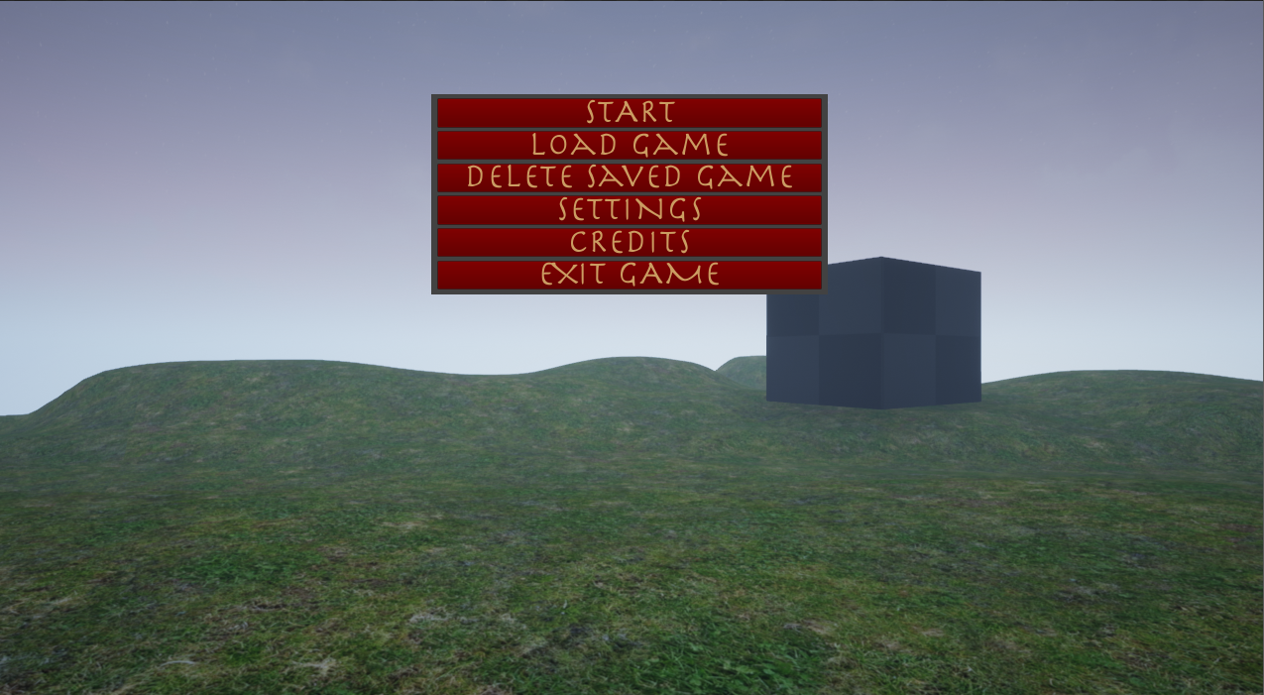

***Figure 3.1-1. Main Menu***

The pause menu, shown below in Figure 3.1-2 can be opened by pressing *P* anytime while in game and not on another menu. To leave the pause menu, simply press *P* again. From the pause menu, the player can load from the save file, open the settings, exit to the main menu, or exit the game. The player can also close this menu by clicking on “Resume”. When pressing “Settings”, the settings menu will appear and the user will be able to interact with it in a similar way. To return back to the pause menu, simply press the back button while on the settings menu.

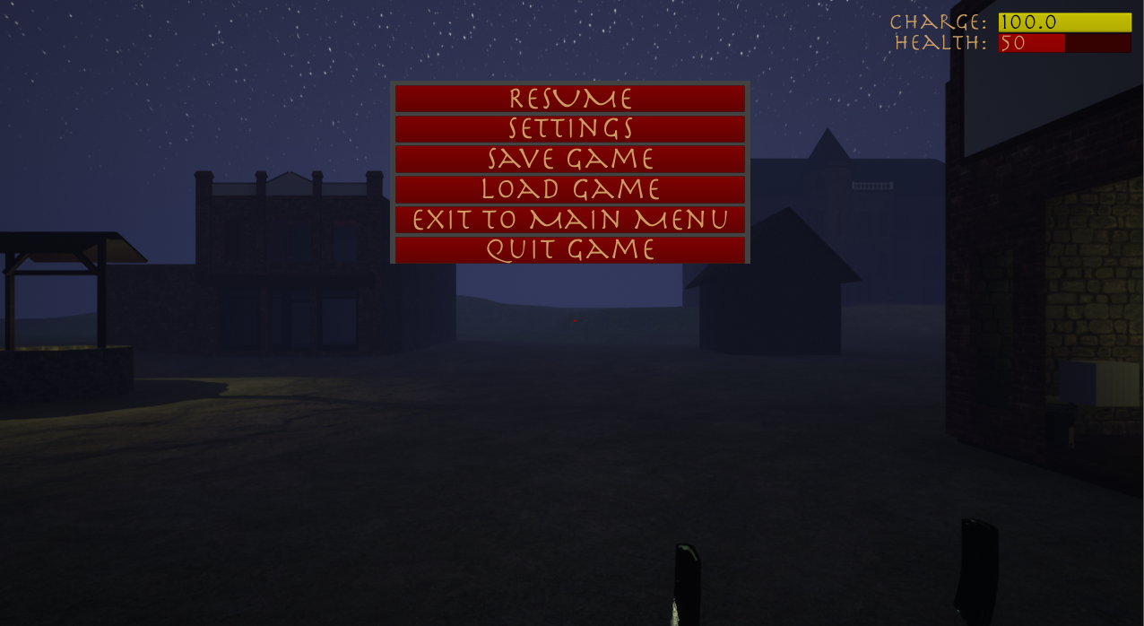

***Figure 3.1-2. Pause Menu***

To access the in game menu shown in Figure 3.1-3, press *I* anytime while playing the game and not on another menu. To leave the in game menu, simply press *I* again. From the in game menu, the player can navigate to different tabs to see descriptions and information about objectives, items, notes, audio logs, artifacts, and perks. Whenever the in game menu is opened, the objectives tab will always be displayed first. The information and navigation of these tabs are explained further below.

Project Night Terror also has other minor menus such as the settings menu and the credits menu. These are easier to understand (such as the credits menu only having a back button) so this document will not cover them, but will instead make a mention of them.

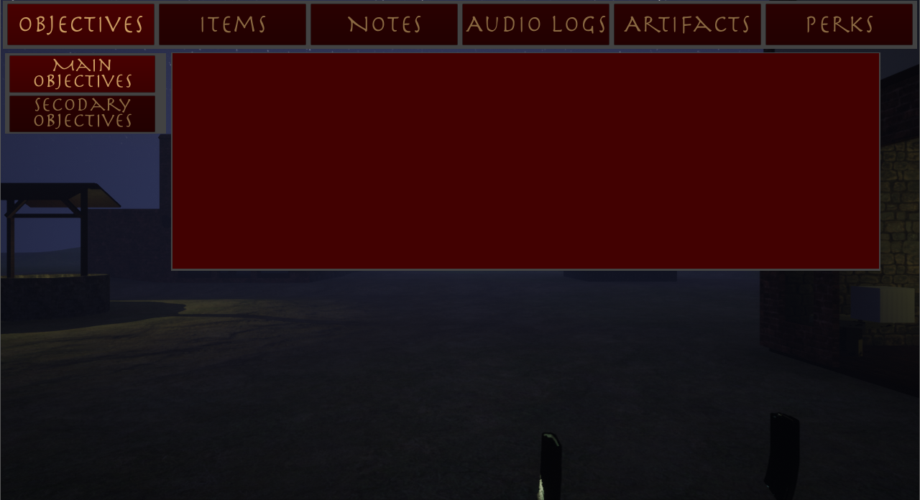

***Figure 3.1-3. In Game Menu***

**3.2 Objectives Menu**

Objectives are split into main objectives and sub objectives, but both can be viewed from the in game menu. When an objective is updated “Main Objective Updated”, “Sub Objective Updated”, or “Objectives Updated” will be displayed in the top left corner of the screen. To view objectives, press *I* to open the in game menu and select either “Main Objectives” or “Sub Objectives”. If there are currently no sub objectives, then the objective will not show anything. Figure 3.2-1 below shows this screen.

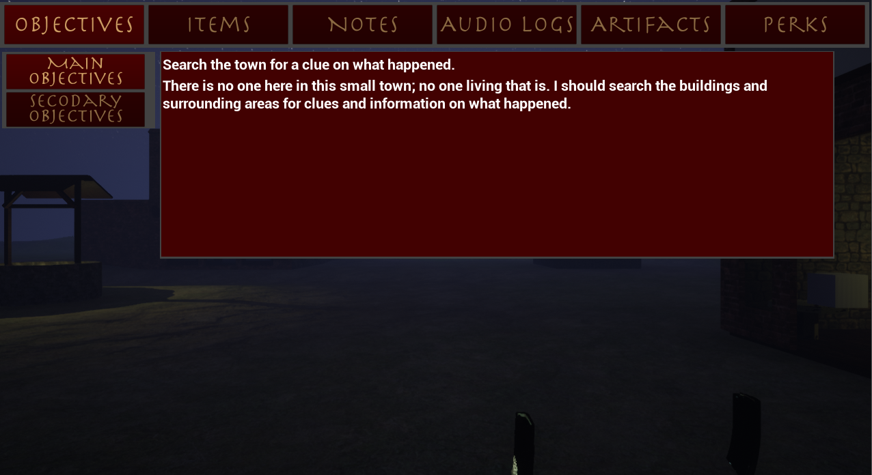

***Figure 3.2-1. Objectives Tab with Main Objectives Selected***

**3.3 Items Menu**

The item menu displays information about items that the player picks up and can use including the flashlight, rifle, pistol, cross, and knife. Once an item has been picked up and obtained, the player can go to this menu by pressing *I*, clicking on “Items”, then clicking on the specific item for its description. If an item has not been unlocked yet, the button will show “??????” and the player will be unable to select it. To exit the in game menu, press *I*. The Item menu is shown below in Figure 3.3-1.

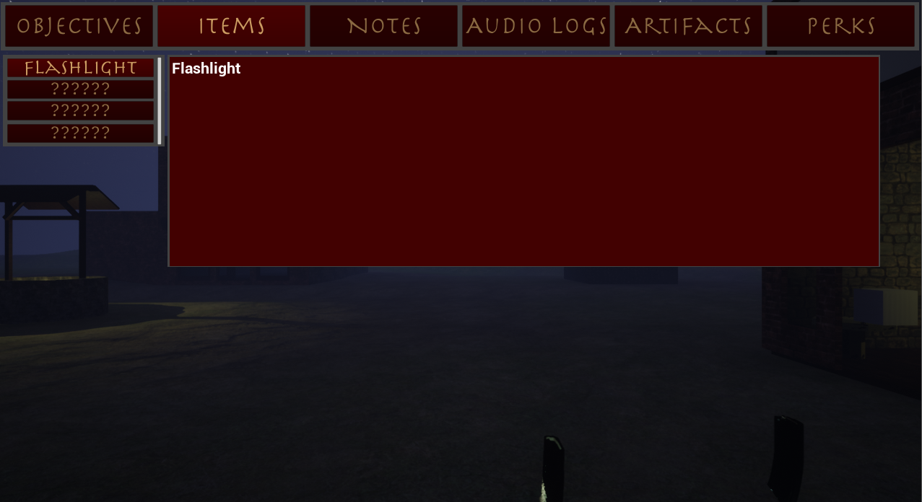

***Figure 3.3-1. Items Tab with Flashlight Selected***

**3.4 Collectables & Other Pickups**

In every level, there are four unique styles of collectables that the player can pickup; notes, audio logs, artifacts, and upgrades. The total number of a specific collectable in a level may be different than other levels. To pick up a collectable, approach it and when prompted, press *E;* shown in Figure 3.4-1. This will add the collectable to the player’s inventory. Upgrades do not have a specific menu, but instead will increase the number of perks that the player can unlock by 1 shown on the perk menu.

To view the collectables that the player has picked up, press *I* to get to the in game menu and then click on “Notes”, “Audio Logs”, or “Artifacts”. From any of these menus select a specific note to read its description or in the case of an audio log, also listen to it. To leave the menu, press *I*. Before selecting a specific collectable and after is shown in Figure 3.4-2 and 3.4-3 respectively.

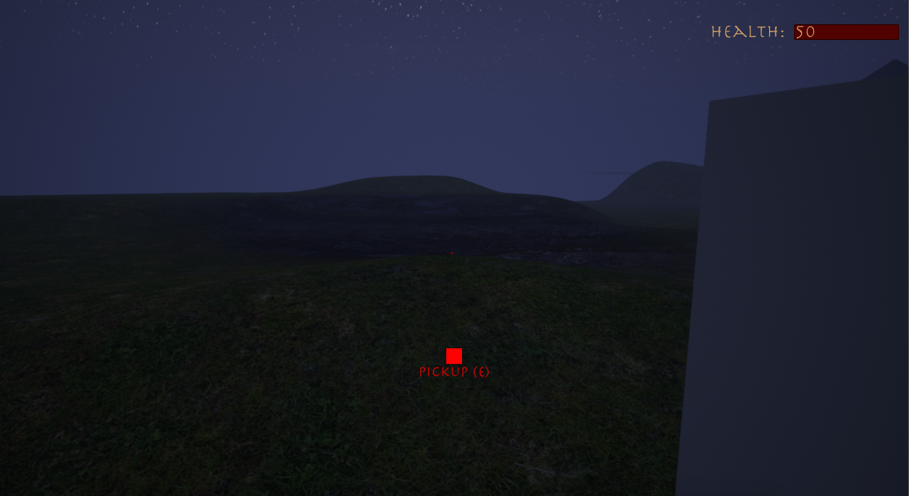

***Figure 3.4-1. Collectable Pickup Prompt***

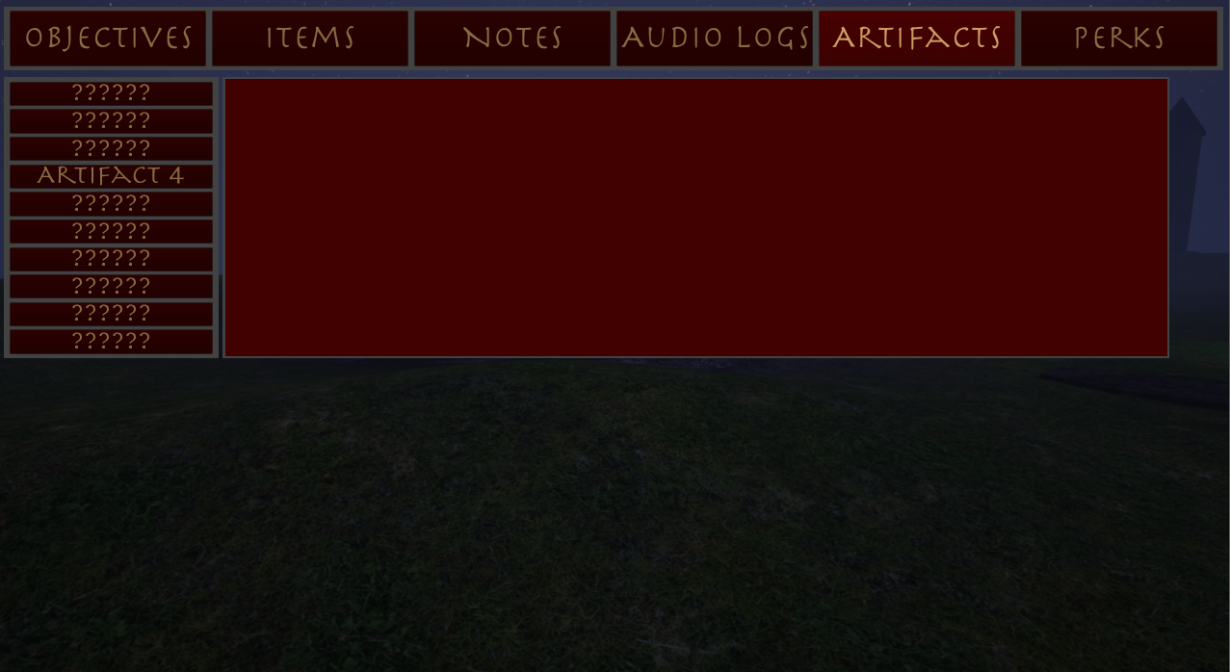

***Figure 3.4-2. Artifact Menu Before Selecting Artifact 4***

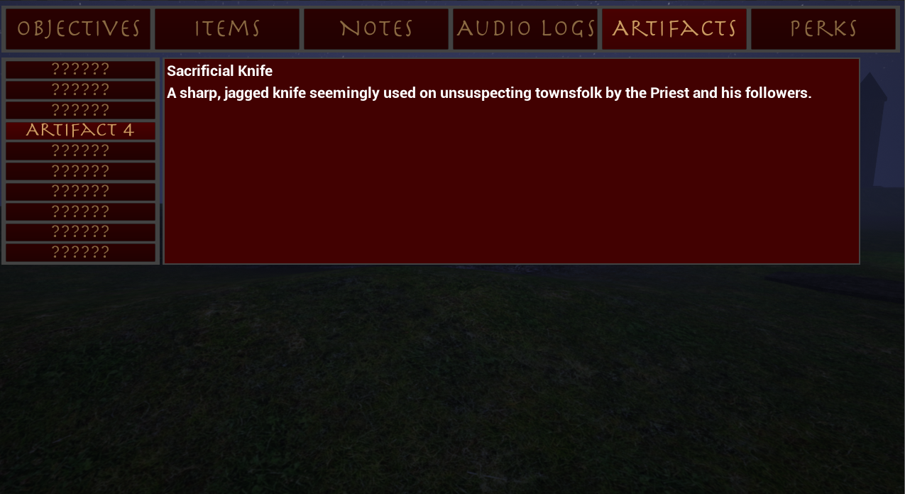

***Figure 3.4-3. Artifact Menu After Selecting Artifact 4***

**3.5 Perks Menu**

Once an upgrade has been collected, press *I* to get to the in game menu and then click on “Perks”. The perk menu is shown below in Figure 3.5-1. From this menu, the player can select any perk to read a short description about it. When the player is ready to choose a perk, they select it and then click the “Confirm” button. If the player does not have any upgrade points then the perk will not be applied. Also, the player must have all parent nodes of a branch unlocked to be able to choose a perk. If the prerequisite nodes are not already unlocked, the perk will not be unlocked.

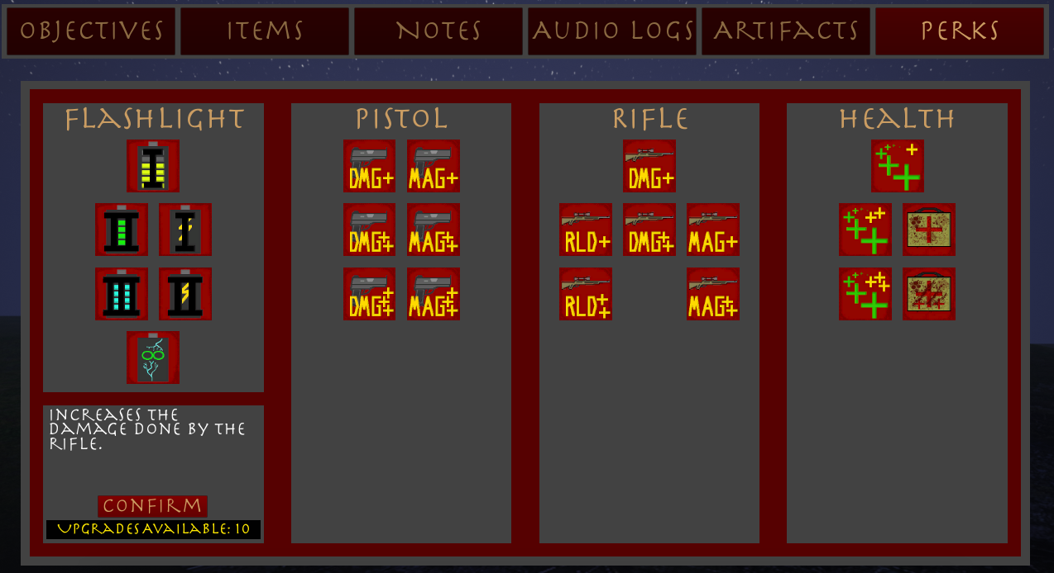

***Figure 3.5-1. Perk Menu***

**4 Normal Gameplay**

**4.1 Button Mappings**

Figure 4.1-1 shows the button mappings of Project Night Terror. There is currently no option to change these configurations inside the game.

***Table 4.1-1. Button Mapping***



**4.2 Attacking**

Throughout the game, the player will find and pickup different weapons to use against the demons in the game. Once a weapon has been found and picked up, the player can press *2* to use the rifle, *3* to use the pistol, *4* to use the cross, or *5* to use the knife. When an item is equipped, the player can use it by clicking the left mouse key. If the player presses *1* then any equipped item will become unequipped.

As opposed to melee weapons, the rifle and pistol will fire and can attack demons at a distance. The player must reload their weapon by pressing *T* when they have run out of magazine ammo. There is a slight delay in reloading and during this time the player cannot fire their weapon. Once reloading is finished, the gun can be fired again. If the player has no ammo, then they will be unable to fire their weapon and must find more to use it again.

To attack with the cross or knife, the user must move close to a demon. This distance is dependent on the item currently equipped; the cross has a further reach and the player can be a bit further away from demons to use it than the knife. Once close enough, the user can begin to attack and the demon will begin to take damage. The player can attack the demon as many times as they want while using a cross or knife, but there is a small delay between strikes.

**4.3 Saving & Loading**

When a level is completed or a new game is started, the game is automatically saved for the player. However, to save manually open the pause menu by pressing *P* then click the “Save” button. Once saved, “Game Saved” will appear in the top left corner of the screen. If a saved game does not exist, the game will automatically create one for the user. To delete a save, go to the main menu and select “Delete Saved Game”.

**WARNING: DO NOT TURN OFF THE COMPUTER OR EXIT THE GAME WHILE THE GAME IS STILL SAVING OR THE SAVE MAY BECOME CORRUPTED.**

To load a previous save open the pause menu by pressing *P* (if the player is at the main menu, they do not need to open the menu). Once the menu is open, click “Load Game”. If there is no saved file then the no game will be loaded and “No Save Exists” will show in the top left corner. If a save file does exist then game will be loaded for the player and “Game Loaded” will appear in the top left corner of the screen.

**4.4 HUD**

To keep the HUD (Heads up Display) simple, normal gameplay only shows the player’s health, the current charge of the flashlight, and a small dot in the middle to help with aiming, movement, etc. It is important to note that before the player has the flashlight, the charge information will not be visible. When either the rifle or pistol is equipped, that specific gun’s ammo information will be displayed along with the health and charge in the top right of the screen. Finally, when objectives are updated “Main Objective Updated”, “Sub Objective Updated”, or “Objectives Updated” will be displayed in the top left corner of the screen.

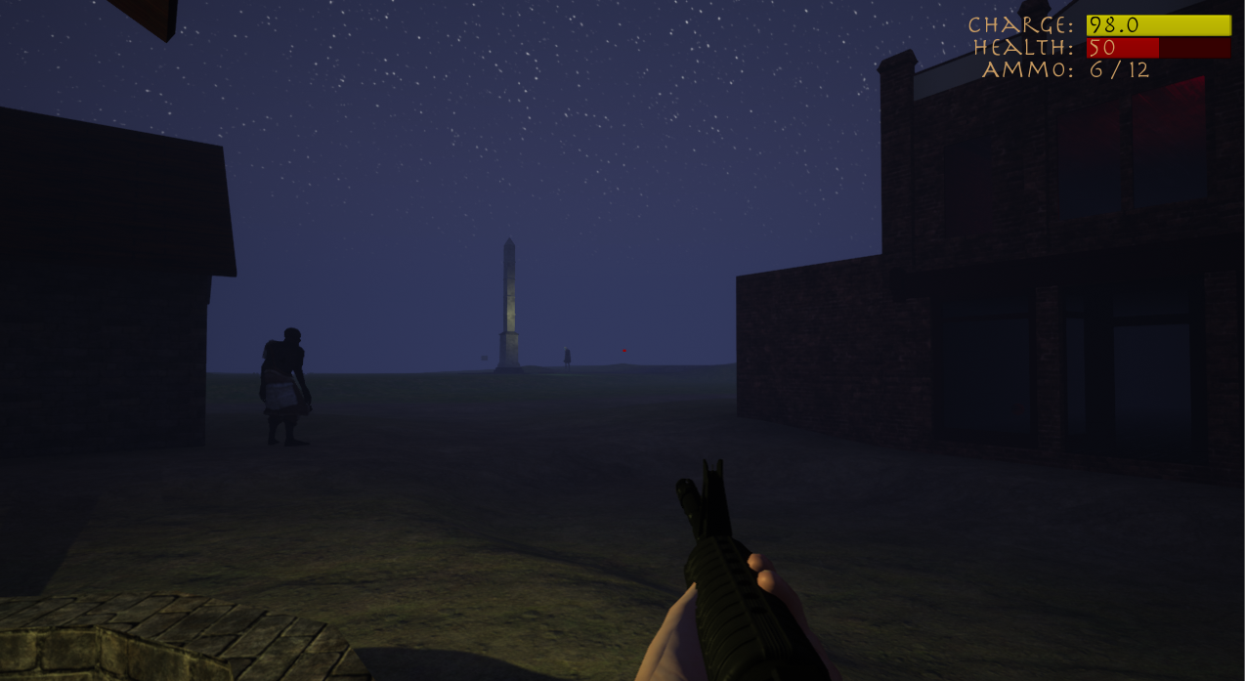

***Figure 4.4-1. HUD with Flashlight & Rifle Equipped***

**5 Startup & Exiting**

**5.1 Starting the Game**

To begin playing Project Night Terror, open the game executable file on the computer where it is saved or downloaded. This will start the game and will automatically have the game go into full screen mode. Once the game is opened, clicking “Start” will open a new game. To load a previously saved game, press “Load Game”.

**5.2 Exiting the Game**

To close Project Night Terror, open the pause menu by pressing *P*. Once the menu is opened, click *Exit Game*. This will close down the application and return the user to their desktop.